High Level Design (HLD)

Adult census Income Prediction

Project done by :- Deepak yadav

Abstract

Recent trends are to build tall buildings in big cities as a way out of the current housing overpopulation problem. These new structures unveil problems that if not addressed in time could cause catastrophes of unimaginable impact. Some of those problems is the incidence of a fire threat happening upstairs in one of those buildings, medical emergencies due to any road accidents or mob that may cause threat to the human kind. This work discusses the implementation of the unmanned ground vehicles to spot the real location of the medical emergencies due to road mishap, mob or illegal activities such as hooliganism, snatching, robbery and the fire emergency and accordingly channelize or route them to the concerned helpline for quick mitigation and avoid disaster.

## Why this High-Level Design Document?

The purpose of this High-Level Design (HLD) Document is to add the necessary detail to the current project description to represent a suitable model for coding. This document is also intended to help detect contradictions prior to coding, and can be used as a reference manual for how the modules interact at a high level.

The HLD will:

* Present all of the design aspects and define them in detail
* Describe the user interface being implemented
* Describe the Education all the people.
* Describe the people’s all necessary things.
* Predict the salary of the people . 

## Scope

The HLD documentation presents the structure of the system, such as the database architecture, application architecture (layers), application flow (Navigation), and technology architecture. The HLD uses non-technical to mildly-technical terms which should be understandable to the administrators of the system.

### Definitions

Term Description

|  |  |
| --- | --- |
| Adult census  Database  IDE  AWS | Adult census Income prediction  Collection of all the information from the data  Visual studio  Amazon Web Services |

# **General Description**

## Product Perspective

The Adult census income prediction is a machine learning based classification result which will help us to find out the people income on the various situation

# **Problem statement**

The Goal is to predict whether a person has an income of more than 50K a year or not.

This is basically a binary classification problem where a person is classified into the

>50K group or <=50K group..

### **PROPOSED SOLUTION**

The solution proposed here is a adult census income predict salary of the people at many situation like education, relationship ,job profession etc...

# **Data Requirements**

Data requirement completely depend on our problem statement.

* We need sufficient amount of the data to predict some result.
* If data are sufficient we can say the model is accurate error free.
* We need to clean all the data and make some statistical understanding.
* We ensure that the given data has no any unwanted values

# **Tools used:-**

Python programming language and frameworks such as NumPy, Pandas, Scikit-learn are used to build the whole model.

Flask 



[This Photo](https://devopedia.org/numpy) by Unknown Author is licensed under [CC BY-SA](https://creativecommons.org/licenses/by-sa/3.0/)



[This Photo](https://lthub.ubc.ca/guides/github-instructor-guide/) by Unknown Author is licensed under [CC BY](https://creativecommons.org/licenses/by/3.0/)

* Visual studio is used as IDE.
* For visualization of the plots, Matplotlib, Seaborn and Plotly are used.
* AWS is used for deployment of the model.
* GitHub is used as version control system.
* Front end development is done using HTML
* Python ,flask is used for backend development

Design Details

Process Flow

For predict people’s salary , we will use a machine learning base model. Below is the process flow diagram is as shown below.

#### **Proposed methodology**

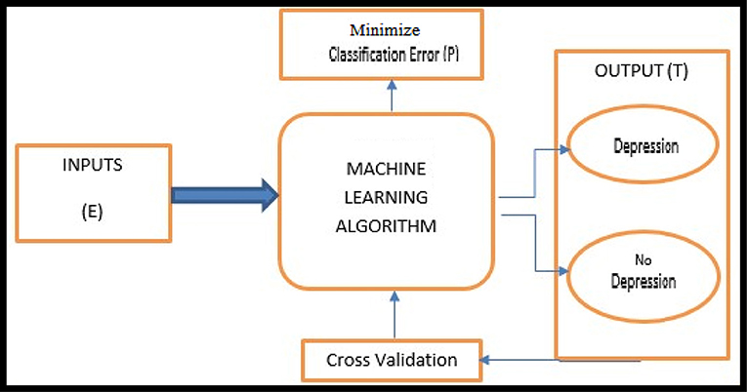

# **Model Training and Evaluation:-**

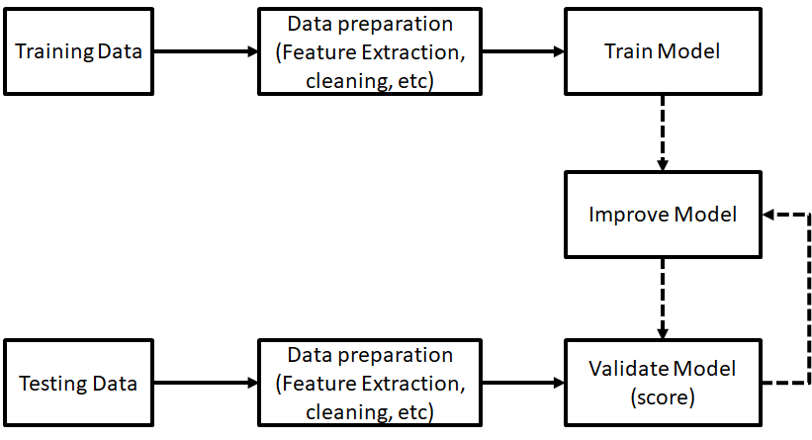

Deployment Process

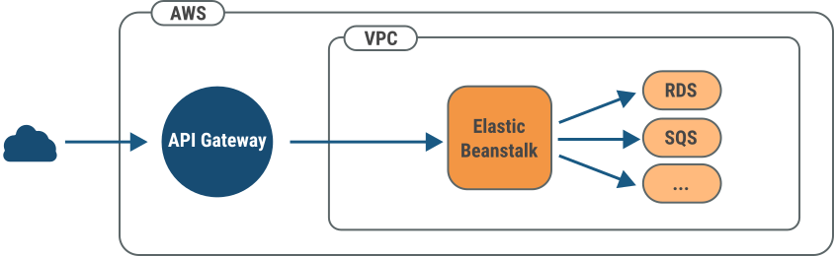

Conclusion

The adult census income prediction will useful for know about income background of the people how earn how much based on there position.